**4. JMeter**

**JMeter Performance Test Report**

|  |
| --- |
| Document Information: |
| **Title**: JMeter Performance Test Report |
| **URL**: https://httpbin.org/ |

**Abstract**

The report indicates performance test done using Apache JMeter.

**Introduction**

Any application has a certain threshold that they can perform. Performance testing is a process of testing a software application under specified workload. The goal is to make sure that the application can function properly after it has been launched. This can also be used to identify bottlenecks. The performance testing tests the speed, scalability and stability of an application.

Performance Testing is conducted in following eight steps.

1. Requirement Gathering
2. Selection of Tools
3. Performance Test Plan
4. Performance Test Development
5. Performance Test Modeling
6. Execution of Test
7. Test Result Analysis
8. Report

Apache JMeter is an open-source Java based software used for load testing and performance testing. The application is platform independent and customizable which has made it highly compatible for usage. They can perform low end performance for different servers.

**Seconds to Delay**

Random delay with maximum delay of 10 seconds (10000 ms) was added into the JMeter test plan for performance testing.

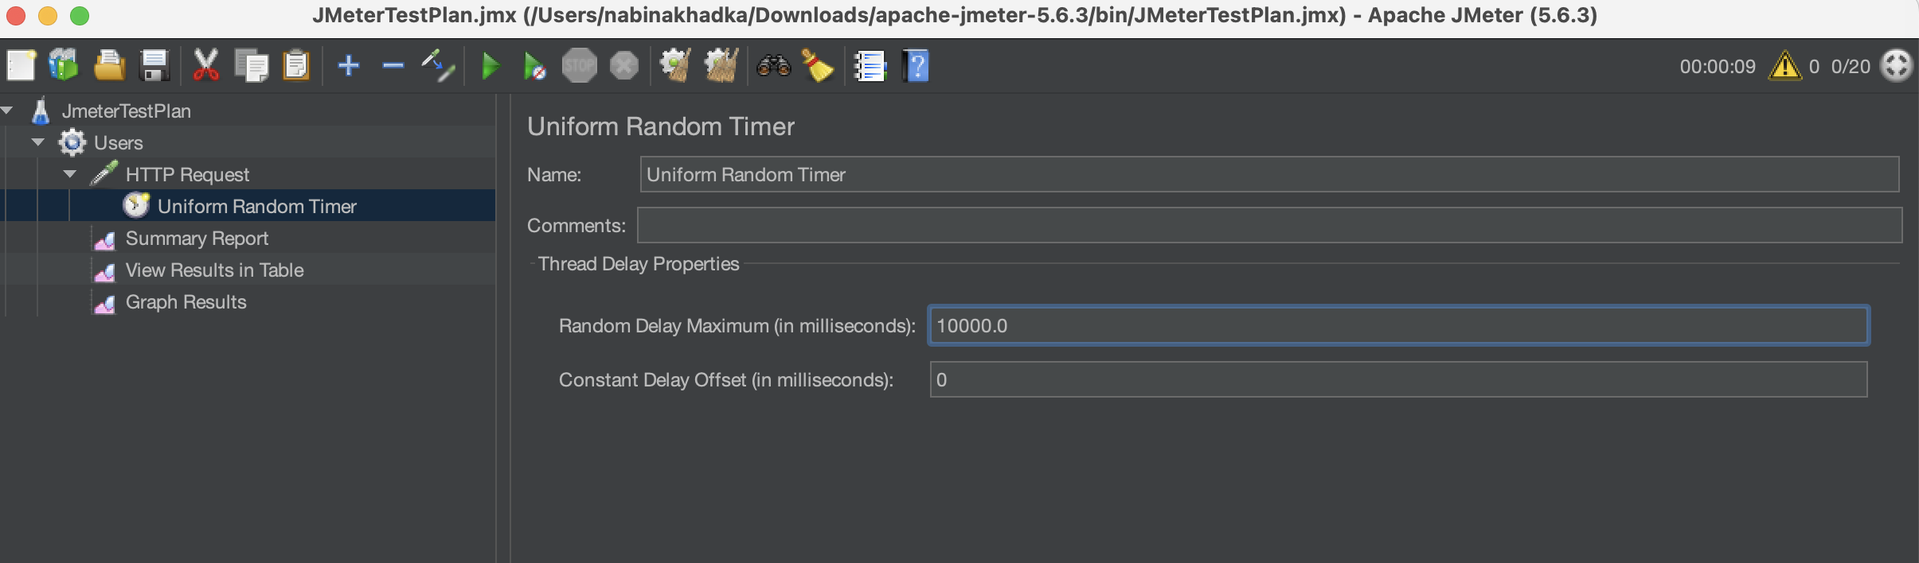

**Test Plan and Result**

The test was conducted for 20 thread users with 10 loop count. There were 3 listeners used for analyzing the result.

The graph shows that our test was stopped after 1minute and11 seconds with a throughput of 48.429/minute. There is also a deviation of 321 in a sample of 800. There is also 0.12 percent error in the given performance test.

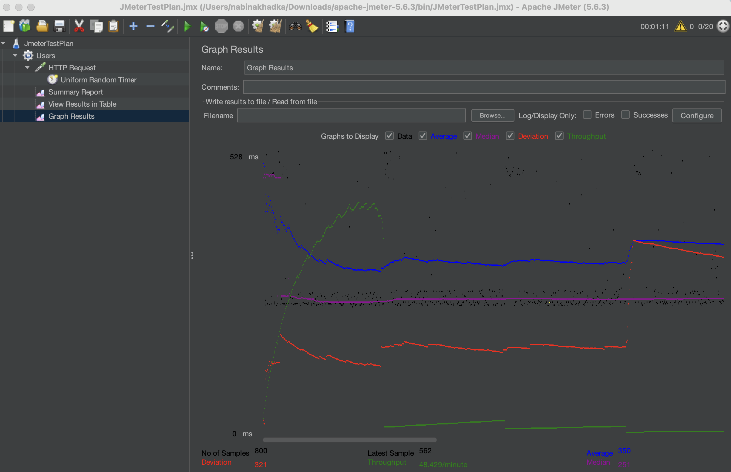

Figure Graph Representation of Performance Testing